## ***Experiment No*:** 03

## ***Experiment Name:***

Process handling in linux.

***Objective:***

In this lab we will try to know how processes are handles in linux terminal and we will try to execute the commands in linux terminal.

***“ls”Command:***  
  
 Used to list folder contents.  You can view many kinds of file and folder attributes.

1. **ls** By itself, ls will simply list all your files in the current folder.  From fact #4, this literally does **ls .**
2. **ls -l** Provides a longer listing format including owners, permissions, size, and date modified.
3. **ls -a** Displays hidden files and folders as well as the normal listing.
4. **ls -al** Combine options to display both hidden files and in the long format.
5. **ls -h** Show file sizes in human readable format (K, M, Gbyte) file sizes instead of bytes.  Often used in conjunction with the **-l** flag.
6. You can view files in directories you are not even in.  If I am in /home/justin/Desktop, and I want to view a file in /home/just in, I can do **ls ../** list files one directory back (and not have to go back to do so.)

***Screenshot:***

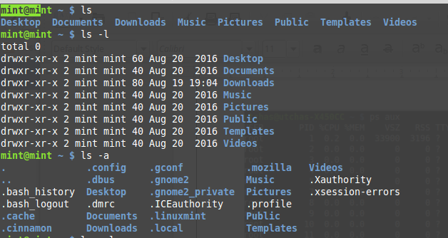

***“Ps” command:***

List processes:

1. **ps aux** List all processes in detail running on the system, including user, Process ID (PID), and name of process.  Using this, one can view their process list and if necessary, kill unnecessary or stalled processes.

*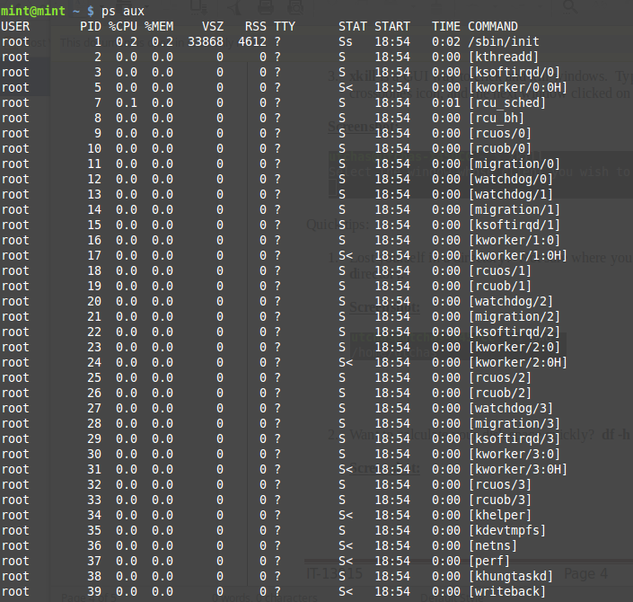****Screenshot:***

***Find out the PID (process id):***

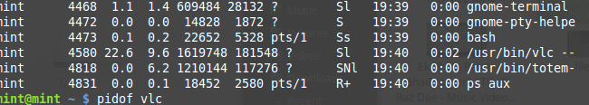Use the ps or pidof command to find out PID for any program  
OR ,

ps aux | grep lighttpd

***Screenshot:***

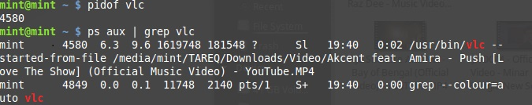

***kill / killall / xkill command:***

Kill offending processes.

1. **Kill PID** PID is a number referencing the offending process.  One should obtain the PID from a command like **ps aux**.  If a process refuses to die, one can alternatively specify **kill -9 PID** which should terminate the process by any means, even uncleanly or if it will mess up the system.
2. Kill the process using process name.
3. kill the process using a PID
4. A note about sending stronger signal # 9 (SIGKILL)
5. If no signal specified in the kill command, signal # 15 (SIGTERM), is sent by default.
6. Sometime signal #15 is not sufficient. For example, vlc may not be killed by signal #15 due to open sockets. In that case process (PID) would be killed with the powerful signal # 9:

***Screenshot:***

E:\fura\9.png

E:\fura\12.png

E:\fura\13.png

E:\fura\11.pngE:\fura\10.png

1. **xkill** is a GUI way to click and kill windows.  Typing in **xkill** should present a skull-and-crossbones icon, and the next window clicked on will be killed.

***Screenshot:***

**E:\fura\14.png**

***Screenshot:***

E:\fura\16.png

1. If we want to calculate our disk space quickly then **df -h** can give us a quick checkup.

***Screenshot:***

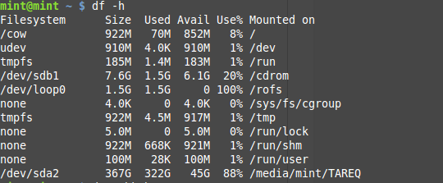

1. Want to calculate the size of a folder or file quickly?  **du -cksh target_name** can do exactly that.  Want to calculate the size of the current folder?  **du -cksh** **.**

***Screenshot:***

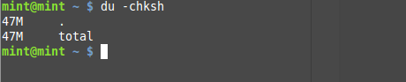

***Discussion:***

We did this lab with the help of our respected conducting teacher, learn about the process handling in linux and executed them with the linux terminal.